Cau 1:
- Use case diagram:
Use case Edit item information
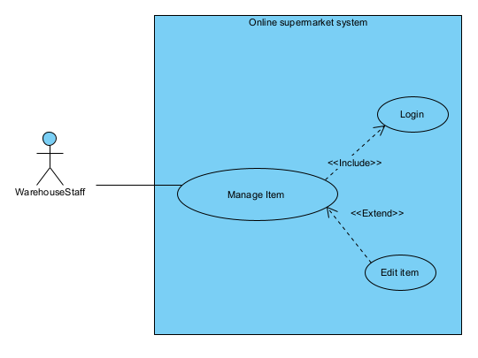
Login: this use case enable the warehouse staff to log into the supermarket system
Manage item: this use case enable the warehouse staff to manage item, action include edit, add, delete item information
Edit item: this use case enable the warehouse staff to edit an item information include name, price, description
Use case Order online
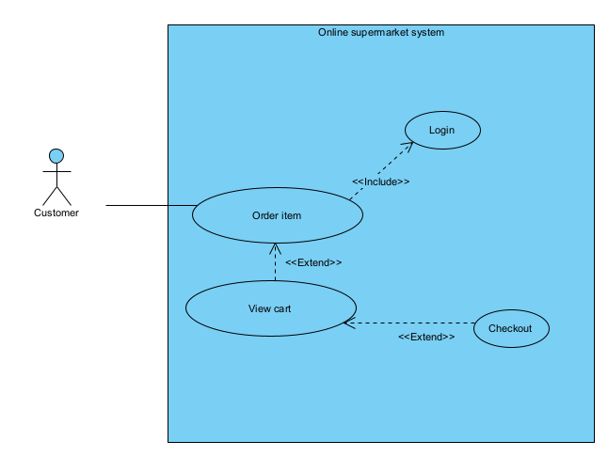
Login: this use case enable the customer to log into the supermarket system
Order item: this use case enable the customer to browse item list, and add item to the cart
View cart: this use case enable the customer to view all item in their cart
Checkout: this use case enable the customer to checkout the item in their cart to place the order
- Scenario
Use case edit item
Use case | Edit item
Actor | Warehouse staff
Pre-condition | Warehouse staff has an warehouse staff account, and the system has at least 1 existing item
Post-condition | The item detail is successfully changed
Main event | - The warehouse staff open the system  - The system show an login interface  - The warehosue staff enter username, password and click login  - The system display the main warehouse staff interface  - The warehouse staff click on item management button  - The system display the item managament interface  - The warehouse staff click the edit button  - The system display the edit item interface  - The warehouse staff enter the item name to the search bar and click enter  - The system display a list of item with the corresponding name  - The warehouse staff click the item they want to change  - The system display a box include item information  - The warehosue staff click the information they want to change, enter new information, and click save  - The system display a success message
Exception | 4. the system display login error  4.1. the warehouse staff click ok button  4.2. the warehosue staff then re-enter the username and password and click login  4.3. the system display the interface in step 4

Use case | Order online
Actor | Customer
Pre-condition | Customer has an account
Post-condition | The order is succesfully placed
Main event | - The customer open the system  - The system show an login interface  - The customer enter username, password and click login  - The system display the main customer interface  - The customer click on place online order button  - The system display the order interface  - The customer enter the item name to the search bar and click enter  - The system display a list of item with the corresponding name  - The customer click the item they want to add  - The system display a box include item information and quantity  - The customer enter the quantity and click add  - The system display success message, and return to the order interface  - Customer then repeat step 7 to 12 for all the item  - The customer then click the view cart button  - The system display the cart interface, with all the item the customer added with the quantity  - The customer click check out  - The system display an interface with the customer information, item list and total  - The customer click checkout  - The system display a success message
Exception | 4. the system display login error  4.1. the customer click ok button  4.2. the customer then re-enter the username and password and click login  4.3. the system display the interface in step 4

Cau 2:
- Extract entity classes
Step 1: descibe the system in a paragraph:
The system is an online supermarket management system with the main user: management staff, warehouse staff, saler and customer. Each user can use the system to do different action. Management staff can view the types of statistics: items, suppliers and revenue. Warehouse staff can import goods from suppliers, manage (add, delete, change) item information and supplier information, browse online orders and export to delivery staff. Saler can process direct order at the counter for customers. Customer can register as a member, search, place online order, buy directly at the counter.
Step 2: extract noun:
- related to people: user, management staff, warehosues staff, saler, customer, delivery staff, supplier, member
- related to things: item, orders, invoice, counter, cart, direct order
- related to system: system, supermarket, statistics, revenue
Step 3: evaluate noun
- system: too ambiguous -> remove
- supermarket: too ambiguous -> remove
- user: make a class User: name, address, phone, username, password, email, role
- management staff: make a class ManagementStaff
- warehouse staff: make a class WarehosueStaff
- saler: make a class Saler
- customer: make a class Customer
- delivery staff: make a class DeliveryStaff
- member: too generic -> remove
- supplier: make a class Supplier: name, phone, email
- item: make a class Item: name, price, description
- order: make a class Order: date, total
- invoice: make a class Invoice: status, dateOfDelivery and ImportInvoice: date
- cart: make a class Cart:
- direct order: make a class DirectOrder: date, total
- online order: make a class OnlineOrder: date, total
- statistics: make class CustomerStatistics, SupplierStatistics, ItemStatistics
- revenue: too generic -> remove
Step 4: Determined the quantity relationship between entity
- 1 Customer has 1 Cart, 1 Cart belong to 1 Customer -> 1-1 relationship
- 1 Item can belong in many ImportInvoice, 1 ImportInvoice has many Item -> n-n relationship -> create class ImportItem: quantity, price
- 1 ImportInvoice has 1 WarehouseStaff, 1 WarehouseStaff can be in many ImportInvoice -> 1-n relationship
- 1 ImportInvoice has 1 Supplier, 1 Supplier can be in many ImportInvoice -> 1-n relationship
- 1 Item can belong in many Cart, 1 Cart has many Item -> n-n relationship -> create class CartItem: quantity
- 1 Item can belong in many DirectOrder, 1 DirectOrder has many Item -> n-n relationship -> create class DirectOrderItem: quantity
- 1 Saler can be in many DirectOrder, 1 DirectOrder has 1 saler -> 1-n relationship
- Each customer can have many OnlineOrder, each OnlineOrder belong to 1 customer -> 1-n relationship
- Each OnlineOrder has many Item, each Item can belong in many OnlineOrder -> n-n relationship -> create class OnlineOrderItem: quantity
- Each order has 1 Invoice, 1 Invoice belong to 1 Order -> 1-1 relationship
- Each WarehouseStaff can approve many Invoice, 1 Invoice can be approved by 1 WarehouseStaff -> 1-n relationship
- Each Invoice can have 1 DeliveryStaff, 1 DeliveryStaff can belong in many Invoice -> 1-n relationship
Step 5: Determined the object relationship between entity
- Inherit relationship(is a):
  - Customer, Saler, ManagementStaff, WarehosueStaff, DeliveryStaff is a User
- Aggregation(has a):
  - DirectOrde has a Saler
  - ImportInvoice has a Supplier
  - ImportInvoice has a WarehouseStaff
  - Cart has a Customer
  - Invoice has a DeliveryStaff
  - Invoice has a WarehouseStaff
  - Invoice has a OnlineOrder
  - OnlineOrder has a Customer
- Association:
  - DirectOrder associate with Item to create DirectOrderItem
  - Item associate with ImportInvoice to create ImportItem
  - Item associate with cart to create CartItem
  - Item associate with OnlineOrder to create OnlineOrderItem
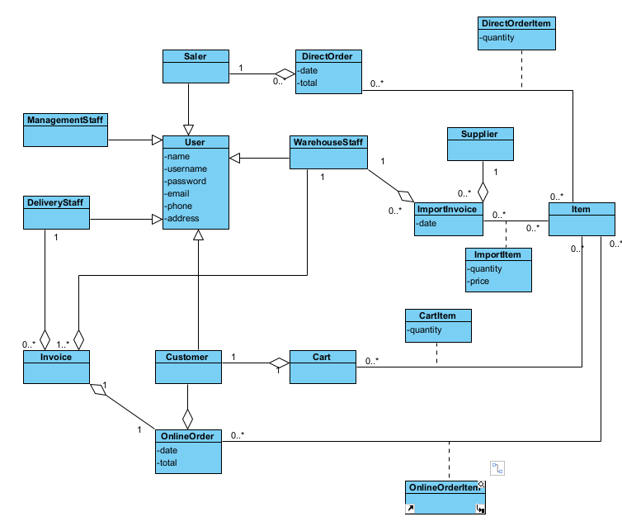

Cau 5:
- Package diagram
For the system, packages are design according to the structure:
- Entity classes are placed together in the Model package
- DAO classes are placed together in the DAO package
- Controller classes are placed together in the Controller package
- JSP pages are placed in the View package. The View packege is further divided into sub packages:
  - Pages related to customer are placed in Customer package
  - Pages related to staff are placed in Staff package
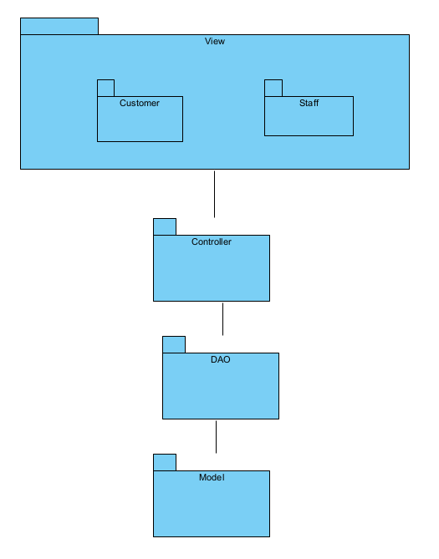
- Deployment diagram

For the system, deployment are design according to the structure:
- Client: many user send request using a Web Browser(Chrome 80+, edge 78+, Firefox 80+)
- Server: 1 node using Apache Tomcat 10.1.24, JDK 23, MySQL Connector 8,4,0, JDBC Driver 12.6.1 to receives requests and excecute logic
- Database: 1 database server queries ans store data in SQL Server 16.0.1160.1
- Commnication path:
  - Client <-> Server: use the http protocol
  - Server <-> databse use jdbc
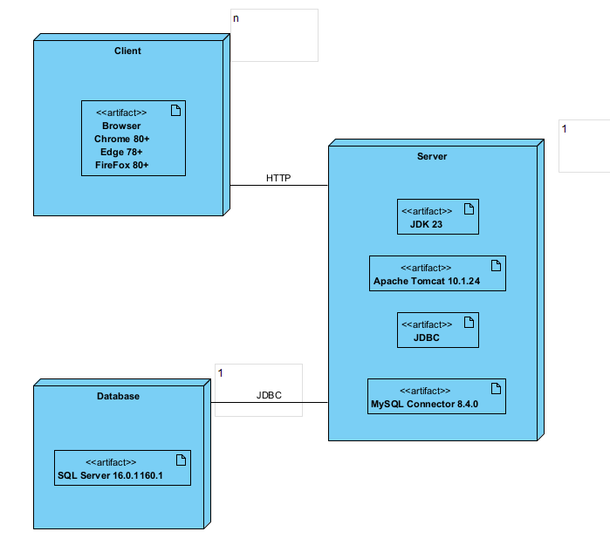
Cau 3:
- Communication diagram
Use case edit item
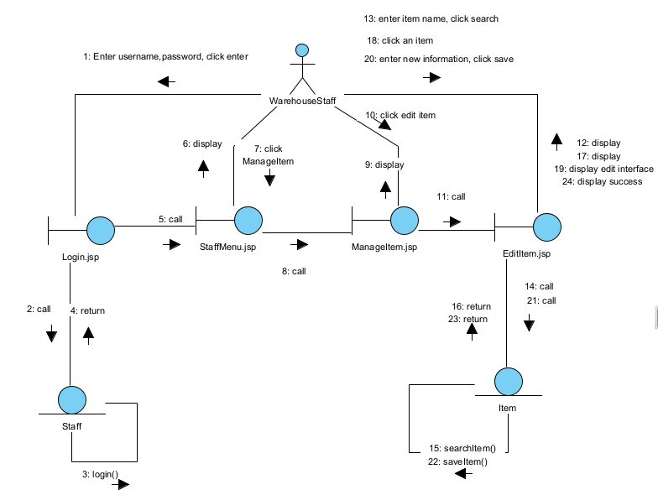
Use case Order online:
